GETTING EMAIL NOTIFICATIONS

 If This Then That allows you to combine different services with your own custom logic. You define what should happen when a condition is met. The potential uses for IFTTT are **endless**.

Channels are the fundamental building blocks of IFTTT. They represent web services that provide data sources or even physical devices like fitness wearables. This allows you to build recipes that use data from projects you’ve personally built, which can then be used to trigger actions elsewhere. Whether that’s from your Arduino-based alarm system, or from your Raspberry Pi powered motion tracker – or your own web project. When you sign up for maker channel(renamed Webhooks), it gives you a secret key. Secret Key is a string of characters which identifies you to the IFTTT servers.

The next step is:

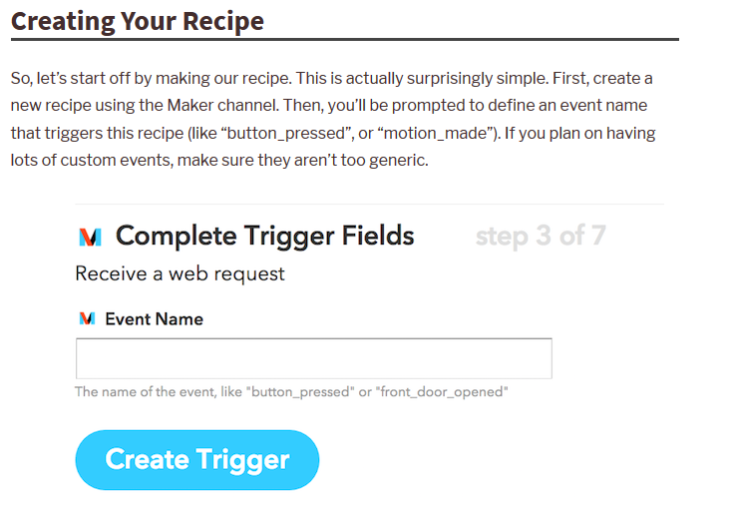

After defining the if “this” trigger fieds, we define then fields:

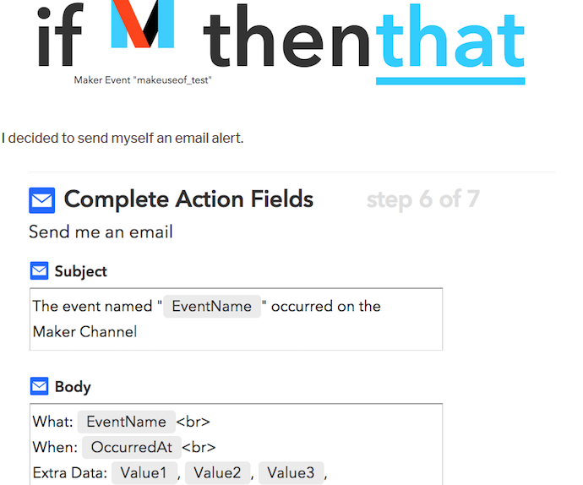

The clear summary is:

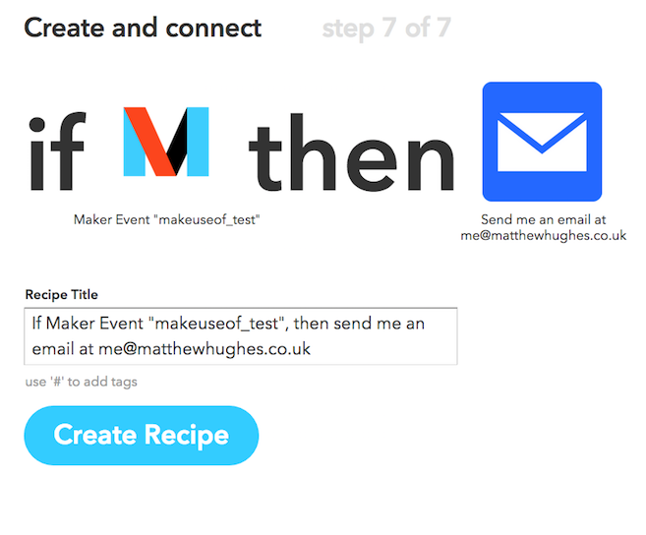

Next step is including code for triggering actions:

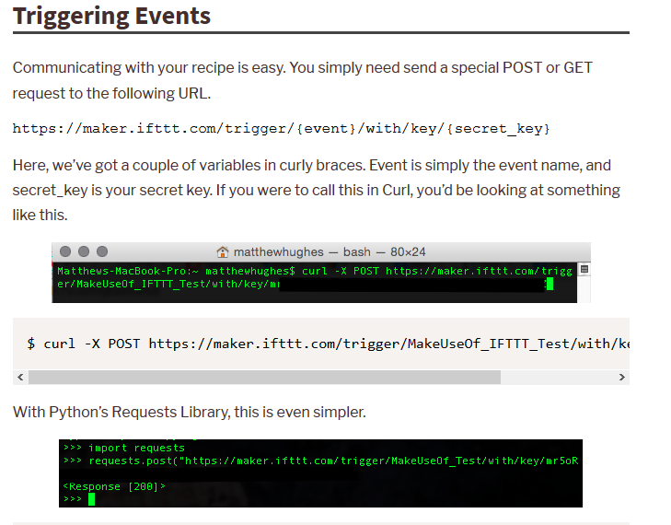

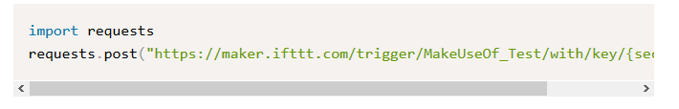

Here, we define two applets light on and light off. Lighting up the led connected to GPIO Pins sends the email notification Light on. Switching off the led sends the notification Light off.

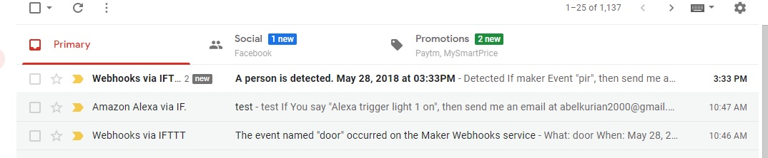

The project can be further extended to detect people using PIR Sensor interfaced to Raspberry Pi.